Quiz 3 NNET and Perceptron Learning

Apply the perceptron learning rule to solve the following problem for w1 = -0.5, w2 = 0.5,
and threshold θ = 1.5. Record the weights and threshold after each step of learning, applying the input patterns in the same order as in the Figure below. Make a table of the results. After one step of learning your table should look like:

Input1 | Input2 | Target | Output | Weight1 | Weight2 | Threshold
1 | 1 | 1 | 0 | -0.5 | 0.5 | 1.5
1 | 0 | 0 | 0 | 0.5 | 1.5 | 0.5

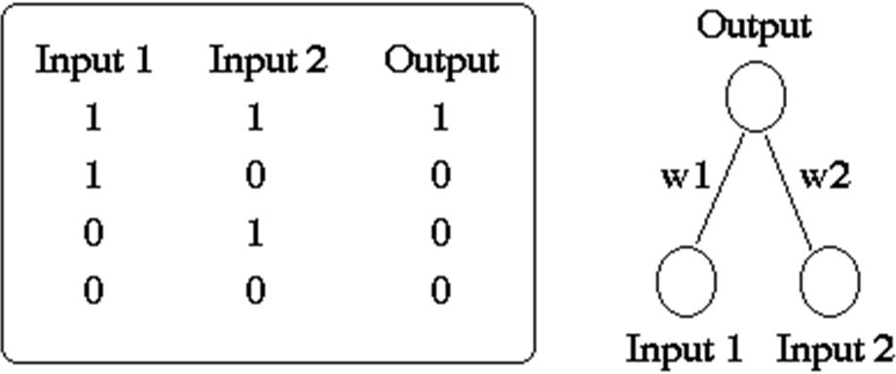
Target

The Network computation and output:
Net = w1I1 + w2I2

if Net > Threshold (θ), then o = 1, otherwise o = 0.

The Perceptron Learning rules:  = (t  o) = d and wi = (t  o)Ii = dIi

❑   + 
and wi  wi + wi

Where I is Input, t is Target, o is Output, d is simply the difference between t and o.
- Use the data points, one by one, in the same order provided in the table and the box above.
- Stop until your algorithm converges, meaning all points being classified correctly (shown on the last 4 rows with the same set of weights and threshold values).
- It is required that you have a simple (typed or computed generated, not hand-drawn and scanned) graph to visualize the 4 data points and the decision boundary resulting from the perceptron learning (the decision boundary should match the weights and threshold on your last low).
- Extra credits will be given for meaningful experiments of 1), learning rates, 2), visualizing updates of decision boundaries, 3). Visualizing updates of the total number of misclassifications in the 2-d w1-w2 space.
- More instructions, tutorials, and Q&As may be provided.

Solution:
Given:

w1 = -0.5, w2 = 0.5, and threshold θ = 1.5

given summation function as Net = w1I1 + w2I2,

Here activation function given as

if Net > Threshold (θ), then o = 1, otherwise o = 0.

Perceptron Learning Rule:

Update for weights:

𝑤𝑖←wi+Δwi

​

Update for threshold:

θ←θ−Δθ

Where, Δwi =η(t−o)Ii

​and Δθ=η(t−o)

Assume a learning rate η=1 for simplicity.

Where I is Input, t is Target, o is Output
Background Notes:

Generally we add bias to shift the activation function to the left or right, which helps the model make better decision boundaries in neural network, but here threshold value is given which is used as a point of comparison against the weighted sum of the inputs. The neuron fires (outputs a 1) if the weighted sum exceeds this threshold, and doesn't fire (outputs a 0) otherwise. (b= -θ)

Here activation function given as, which resembles the sigmoid function.

If actual target = output, then weights are fixed.

If actual target != output, then weights need to be updated.

Input Data:

Input 1 | Input 2 | Target
1 | 1 | 1
1 | 0 | 0
0 | 1 | 0
0 | 0 | 0

Final Expected Table:

 | Input 1 | Input 2 | Target | Output | Weight1 | Weight2 | Threshold
Epoch1 | 1 | 1 | 1 | 0 | -0.5 | 0.5 | 1.5
 | 1 | 0 | 0 | 0 | 0.5 | 1.5 | 0.5
 | 0 | 1 | 0 | 1 | 0.5 | 1.5 | 0.5
 | 0 | 0 | 0 | 0 | 0.5 | 0.5 | 1.5
Epoch2 | 1 | 1 | 1 | 0 | 0.5 | 0.5 | 1.5
 | 1 | 0 | 0 | 1 | 1.5 | 1.5 | 0.5
 | 0 | 1 | 0 | 0 | 0.5 | 1.5 | 1.5
 | 0 | 0 | 0 | 0 | 0.5 | 1.5 | 1.5
Epoch3 | 1 | 1 | 1 | 1 | 0.5 | 1.5 | 1.5
 | 1 | 0 | 0 | 0 | 0.5 | 1.5 | 1.5
 | 0 | 1 | 0 | 0 | 0.5 | 1.5 | 1.5
 | 0 | 0 | 0 | 0 | 0.5 | 1.5 | 1.5

Visualization of Decision Boundary:
weight1 | weight2 | Threshold
0.5 | 1.5 | 1.5

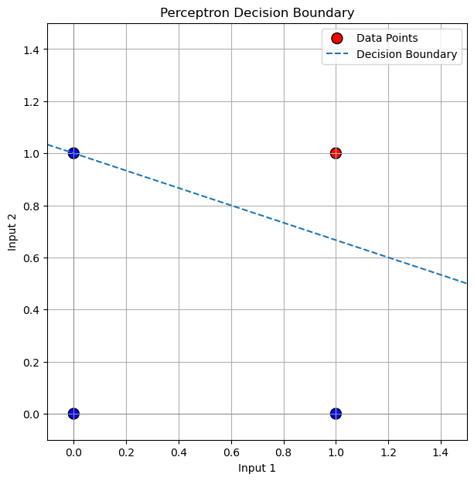

Visualization of Decision Boundary with all weights:
weight1 | weight2 | Threshold
-0.5 | 0.5 | 1.5
0.5 | 1.5 | 0.5
0.5 | 0.5 | 1.5
1.5 | 1.5 | 0.5
0.5 | 1.5 | 1.5

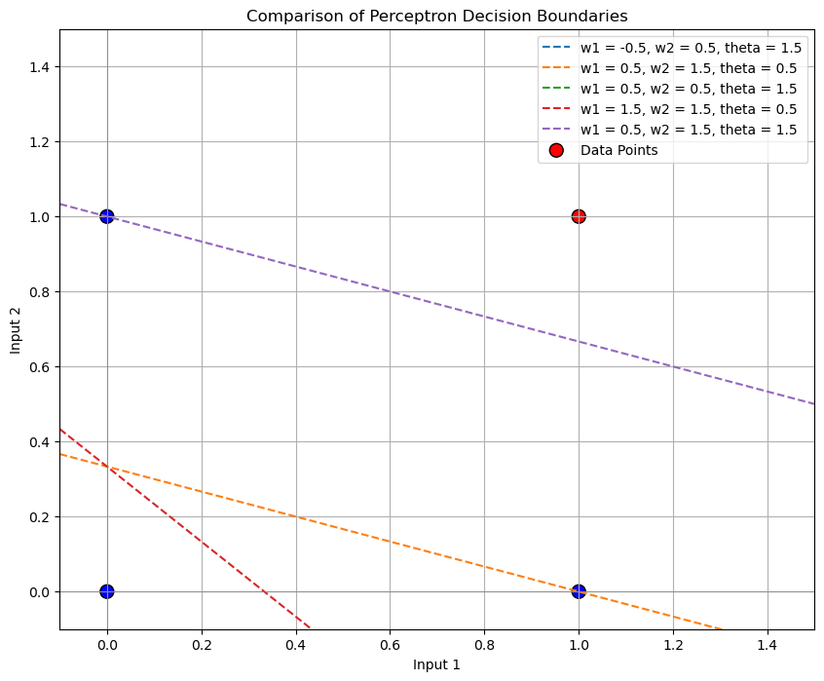

Calculations behind the Final table:

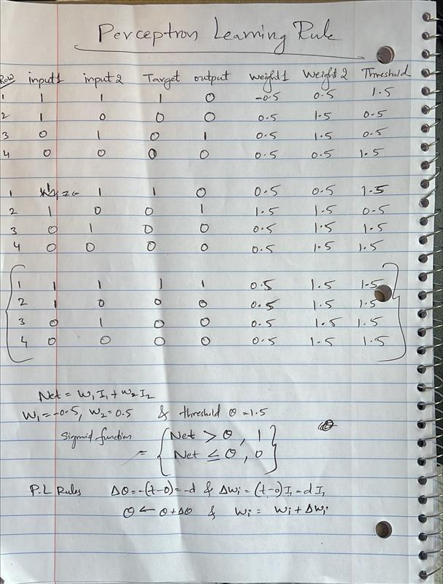

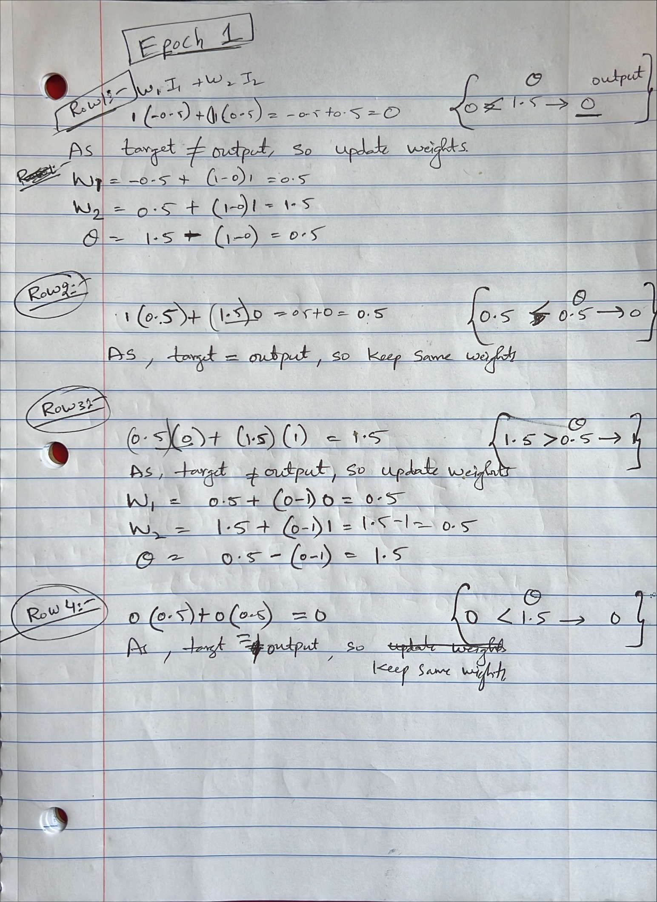

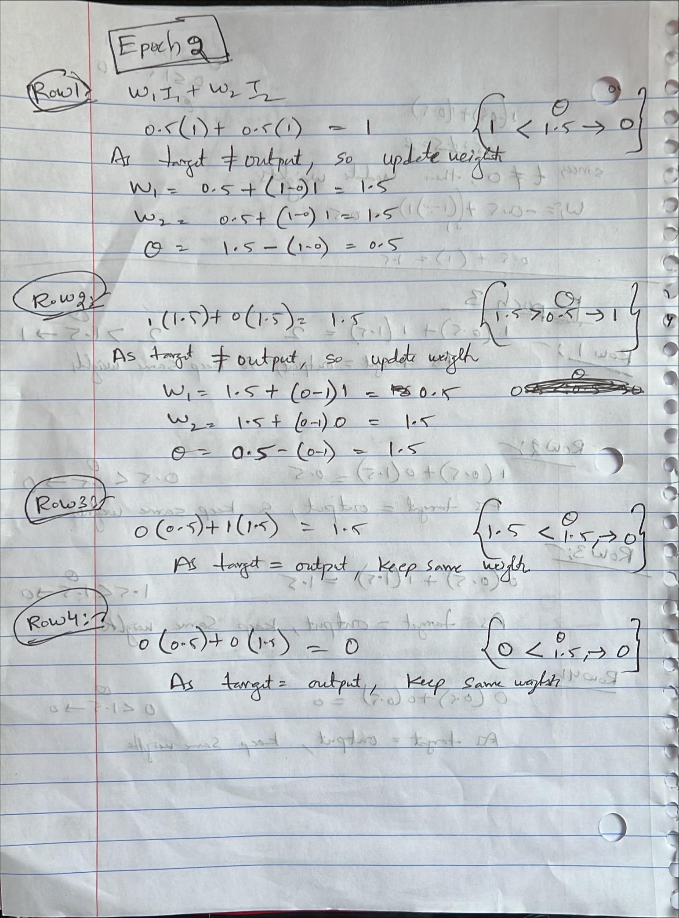

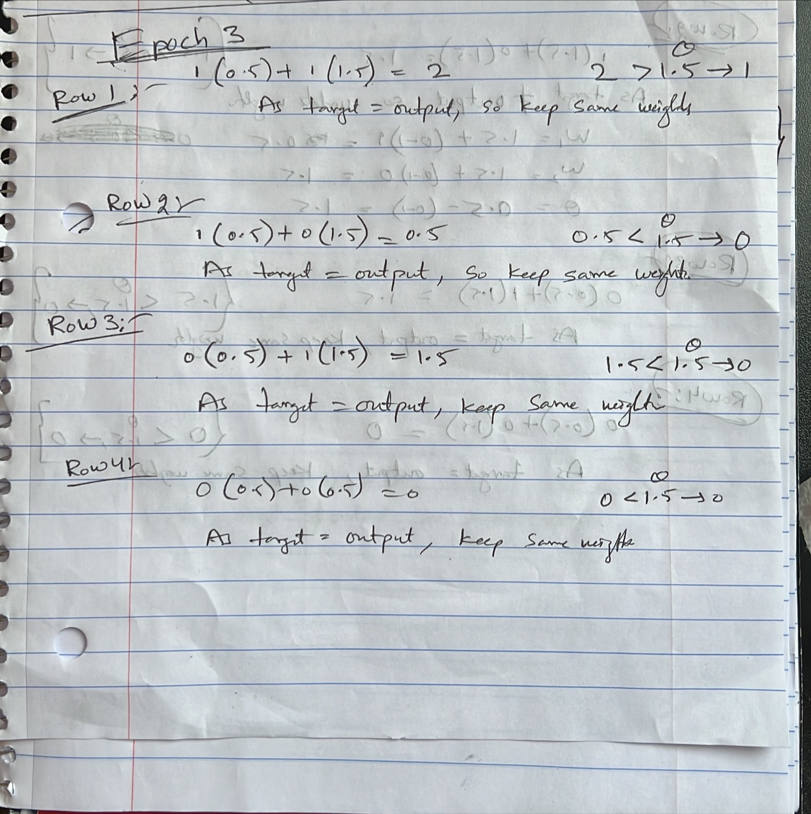

Python Code for Visualization:
import matplotlib.pyplot as plt
import numpy as np

# Define the data points and their classifications
inputs = np.array([[1, 1], [1, 0], [0, 1], [0, 0]])
targets = np.array([1, 0, 0, 0]) # Target classification: 1 or 0

# List of weight and threshold configurations
weights_thresholds = [
(-0.5, 0.5, 1.5),
(0.5, 1.5, 0.5),
(0.5, 0.5, 1.5),
(1.5, 1.5, 0.5),
(0.5, 1.5, 1.5)
]

# Create the plot
plt.figure(figsize=(10, 8))

for w1, w2, theta in weights_thresholds:
# Decision boundary equation derived from w1 * I1 + w2 * I2 - theta = 0
x = np.linspace(-0.1, 1.5, 300) # X range
y = (theta - w1 * x) / w2 # Y values based on the decision boundary formula

# Plot each decision boundary
plt.plot(x, y, label=f'w1 = {w1}, w2 = {w2}, theta = {theta}', linestyle='--')

# Plot data points
plt.scatter(inputs[:, 0], inputs[:, 1], c=['red' if t == 1 else 'blue' for t in targets], edgecolors='k', s=100, label='Data Points')

# Plot formatting
plt.xlim(-0.1, 1.5)
plt.ylim(-0.1, 1.5)
plt.xlabel('Input 1')
plt.ylabel('Input 2')
plt.title('Comparison of Perceptron Decision Boundaries')
plt.axhline(0, color='grey', linewidth=0.5)
plt.axvline(0, color='grey', linewidth=0.5)
plt.grid(True)
plt.legend()
plt.show()

